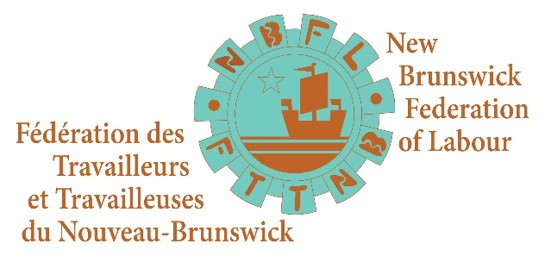
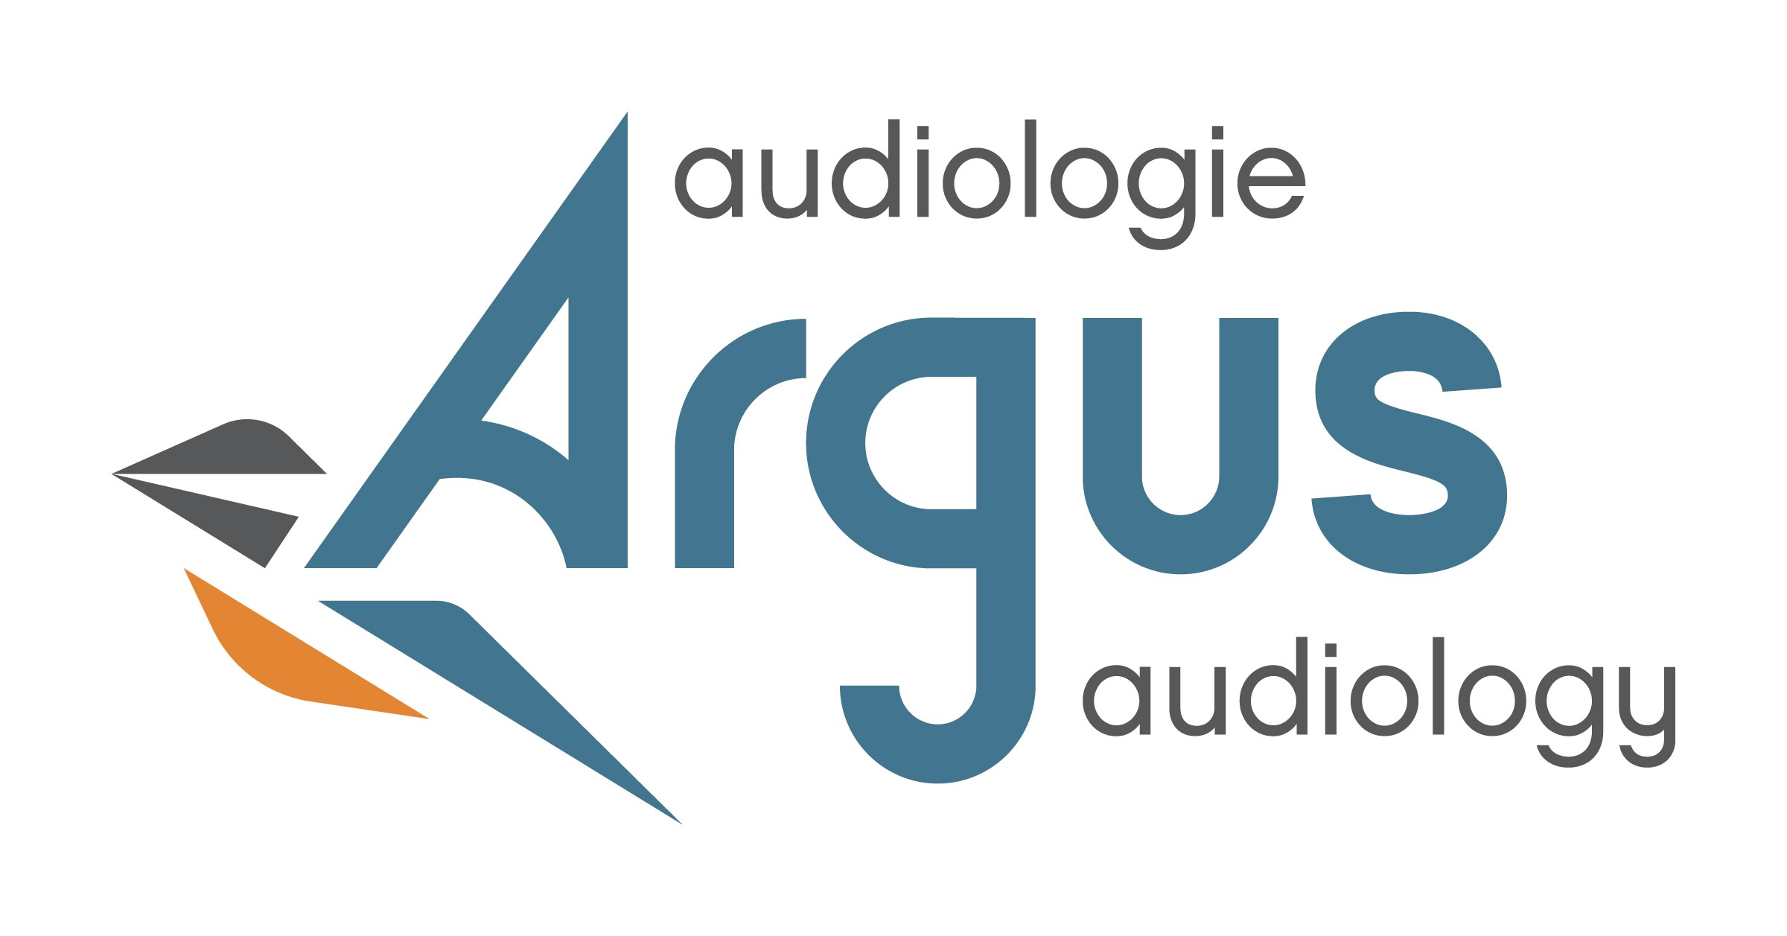

New Award to Recognize Excellence in Trade Unionism

For Immediate Release February 4, 2020

Argus Audiology collaborated with the New Brunswick Federation of Labour (NBFL) to create an annual award called the Owen MacLennan Trade Unionist of the Year. It recognizes individual trade unionists who have made a significant and/or ongoing contribution to the labour movement.

This award is created in the loving memory of Owen MacLennan who worked at Eastern Bakeries from 1951 to 1994. He had a strong work ethic and was an active member of the Bakery, Confectionary, Tobacco and Grain Millers Union (BCTGM) local 406 in Moncton. Brother MacLennan passed away in 2010.

“The New Brunswick Federation of Labour is thrilled to partner with Argus Audiology on the Owen MacLennan Trade Unionist of the Year Award,” says Daniel Legere, President of the New Brunswick Federation of Labour. “It is important that we take the time to acknowledge and celebrate individuals who have made a significant and/or ongoing contribution to the labour movement.”

A donation in the amount of $1,000 will be made by Argus Audiology in the name of the yearly award recipient to the New Brunswick Federation of Labour (NBFL) Blair Doucet Youth Summer Camp. The presentation of the award will be made during Labour Day weekend each year. Award recipients will also be formally recognized during the NBFL Convention.

“I attribute our success today to the strong work ethic that I learned from my Dad, believing that there is no task ever beneath me and that a hard day’s work is normal,” says Norma Eaton, Co-owner of Argus Audiology and daughter of Owen MacLennan. “Argus Audiology is honoured to be part of this award and proud to support our numerous clients that belong to a labour union.” Bill Eaton, co-owner and son-in-law, comments, “Owen forever influenced my perspective of the New Brunswick trade unionist. His compassion, commitment to family and his unmatchable work ethic left me completely in awe.”

Nominees must be an individual, either member or staff of a union local affiliated to the NBFL. Nominations must be received no later than June 30th.

-30-

For information please contact:
Daniel Legere Bill Eaton
President, NBFL Co-owner Argus Audiology
506-857-2125 (w) / 506-381-8969 (c) 506-588-0995 (c)

